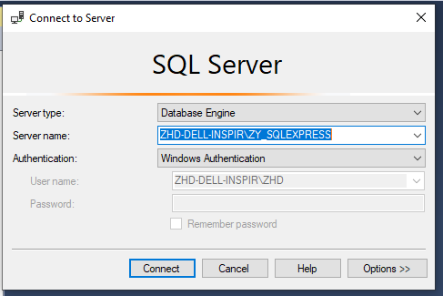
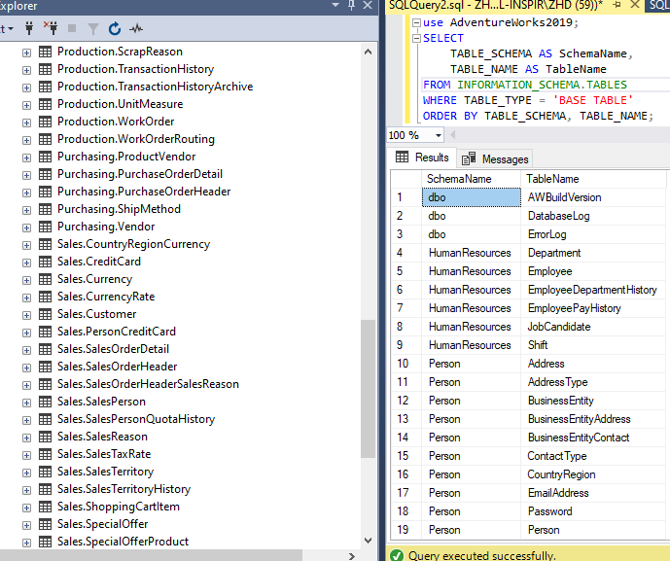
Date Table
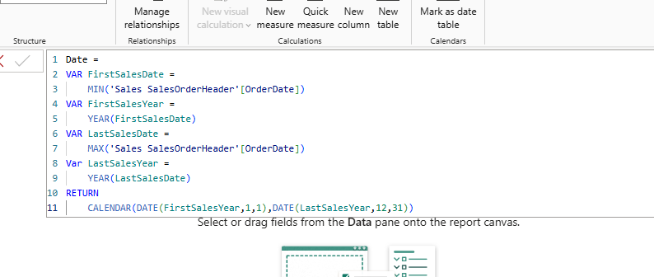
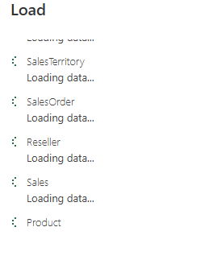
Model View:
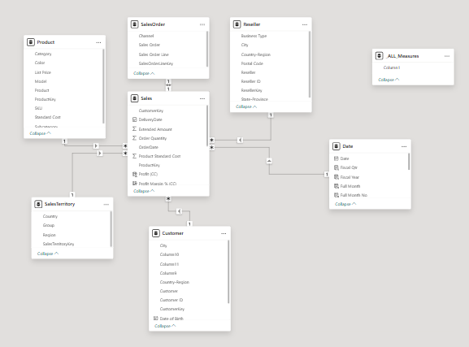
Calculated Column:
Profit (CC) = Sales[Sales Amount]-Sales[Total Product Cost]
Profit Margin (CC) = Sales[Profit (CC)]/Sales[Sales Amount]

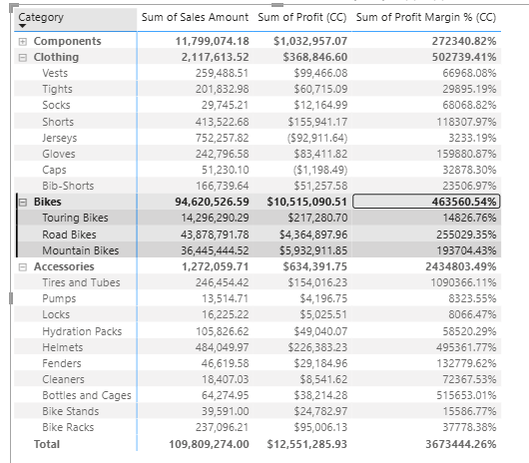
Notice that none of the aggregation available suits the requirement of percentage ∑𝑃𝑟𝑜𝑓𝑖𝑡 calculation because
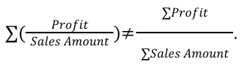
Calculated Measure:
Profit (CM) = SUM(Sales[Sales Amount]) - sum(Sales[Total Product Cost])
Profit Margin % (CM) = [Profit (CM)]/SUM(Sales[Sales Amount])

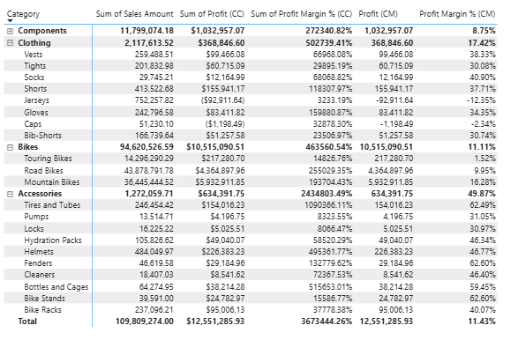
When to use Calculated Column (CC):

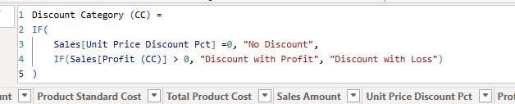
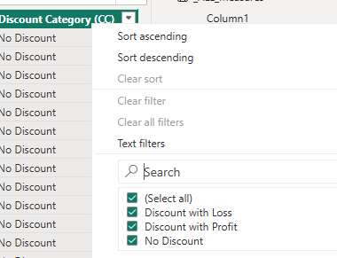
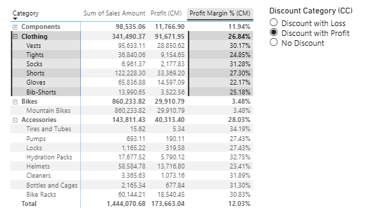
Calculated Column  - Slice or filter values  - Categorize texts/numbers  - Expressions that are strictly bound to current row  - Consume Memory  - Calculated at refresh time  - Data can be seen in the Data tab |  |  | Calculated Measures  - Calculate percentages  - Calculate Ratios  - Complex aggregations  - Consume CPU  - Calculated on the fly
DIVIDE()
Total Cost (CM) = SUM(Sales[Total Product Cost])
Mark UP (CM) = DIVIDE([Profit (CM)],[Total Cost (CM)],0)

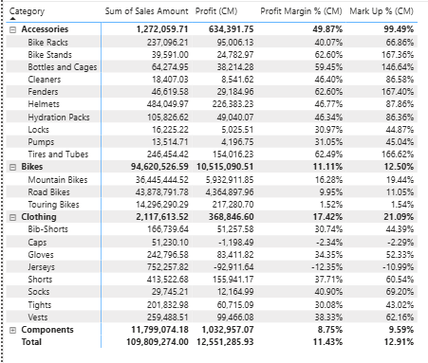
COUNT(), COUNTROWS, DISTINCTCOUNT:
Total No of Product (CM) = COUNT('Product'[ProductKey])
Total No. of Sales (CM) = COUNTROWS(Sales)
Total No of Product Sold (CM) = DISTINCTCOUNT(Sales[ProductKey])
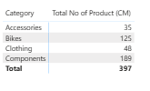
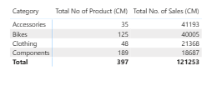
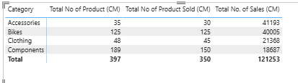
Min, Max and Average
Min Unit Price (CM) = MIN(Sales[Unit Price])
Average Unit Price (CM) = AVERAGE(Sales[Unit Price])
Max Unit Price (CM) = MAX(Sales[Unit Price])

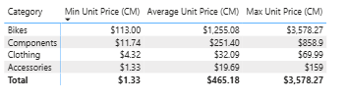
COUNTBLANKS
Total Reseller (CM) = COUNT(Reseller[ResellerKey])
Reseller without Postal Code (CM) = COUNTBLANK(Reseller[Postal Code])

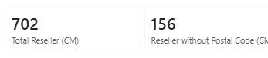
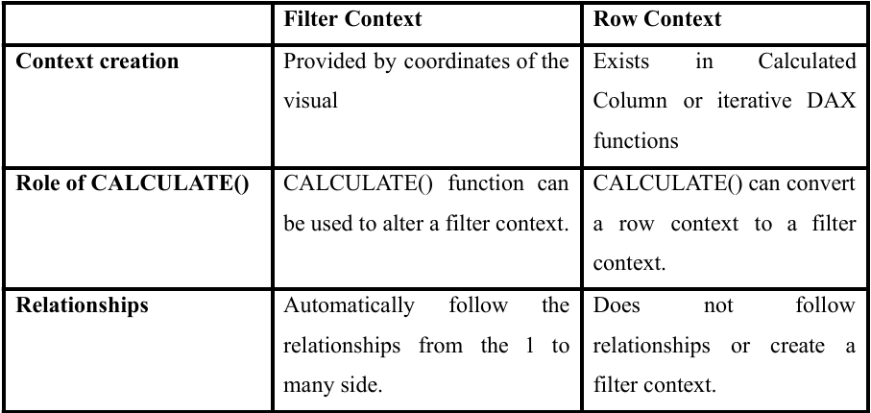
📄 Row Context
- What it is:
Row context means that when DAX evaluates an expression, it looks at one row at a time.
- Where it happens:
  - In calculated columns → each row is evaluated separately.
  - In iterators (like FILTER(), SUMX(), AVERAGEX(), ADDCOLUMNS()) → the function goes row by row through a table, creating a row context for each row.
- Important to know:
  - Row context does not automatically follow relationships between tables.
  - Row context does not create a filter context by itself.
  - To turn row context into filter context, you need special functions (like CALCULATE).
- Measures vs. Row Context:
  - Calculated columns and iterators have row context.
  - Regular measures do not have row context because they work on entire columns/tables, not individual rows.
  - If you want row-by-row evaluation inside a measure, you must use an iterator (like SUMX).

✅ In short:
Row context = “DAX is looking at one row at a time.”
It exists in calculated columns and iterators, but not in regular measures unless you use an iterator.

📄 Filter Context
- What it is:
Filter context means the set of filters applied to your data model when DAX evaluates an expression. It defines which rows of data are visible at the time of calculation.
- Where it comes from (initial filter context):
✔ Slicers on a report
✔ Fields in visuals (e.g., rows and columns in a Matrix)
✔ Page or report filters
✔ Other visuals that cross-filter
- How it behaves:
  - Filters automatically follow relationships in the data model (from the “one” side to the “many” side).
  - You can modify or replace filter context using the CALCULATE() function, which changes the filters before evaluating the expression.

✅ In short:
Filter context = “Which rows are included in the calculation.”
It comes from slicers, visuals, and filters, and can be changed with CALCULATE().

Initial or incoming filter context
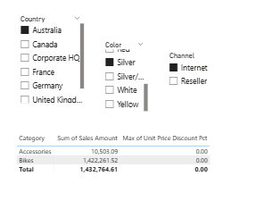 |  | 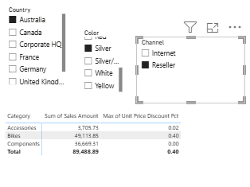
The Unit price discount was applicable for purchases through resellers only
📄 Evaluation Context in Functions
Different DAX functions change or use evaluation context in specific ways. Here are some common examples:
- RELATED() → Expands the current row context to bring in values from another table (like a VLOOKUP).
- FILTER() → Creates a new filter context by selecting only a subset of rows that meet certain conditions.
- ALL() → Removes all filters, so calculations are done on the entire table or column.
- ALLEXCEPT() → Removes all filters except the ones you specify, letting you keep certain filters while ignoring others.
- EARLIER() / EARLIEST() → Used in calculated columns to reference values from an outer row context when working inside nested row evaluations (like looping through rows).

RELATED()
Current List Price (CC) = RELATED('Product'[List Price])
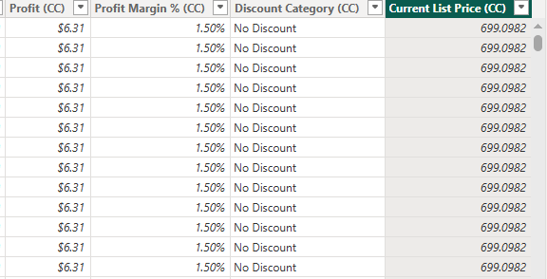
Relatedtable()
No of Sales (CC) = COUNTROWS(RELATEDTABLE(Sales))
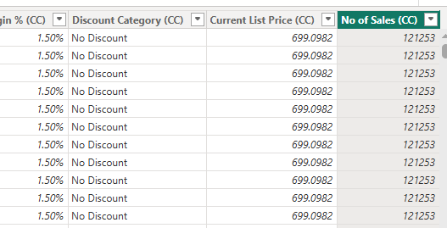
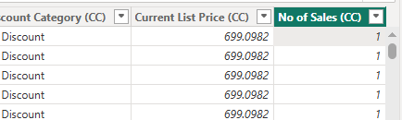
DISTINCTCOUNT()
No of Sales (CC) = COUNTROWS(RELATEDTABLE(Sales))
Last Order Date (CC) = CALCULATE(MAX(Sales[OrderDate]))
No of Product purchased (CC) = DISTINCTCOUNT(Sales[ProductKey])
No of Product purchased CAL (CC) = CALCULATE(DISTINCTCOUNT(Sales[ProductKey]))

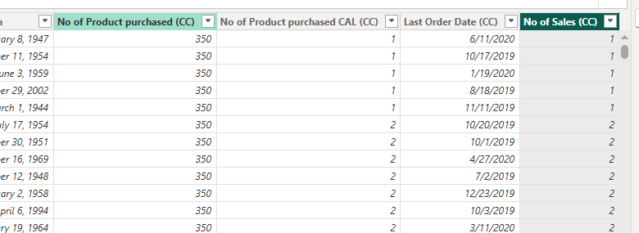
VALUE()
Testing _CT _ VALUES_ Product (CT) = VALUES('Product') // Whole Table

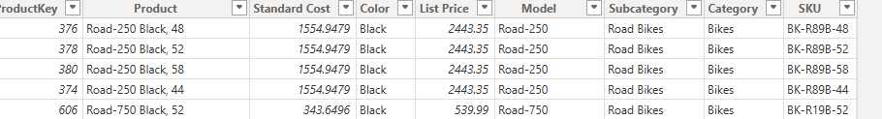
Testing _CT _ VALUES_ Product (CT) = VALUES('Product'[Category]) // Specific Column

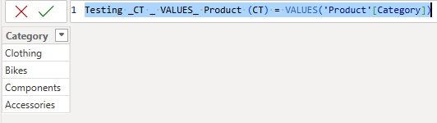
DISTINCT()
Testing _CT _ VALUES_ Product (CT) = DISTINCT('Product'[Category])

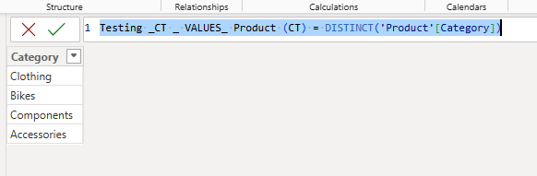
ALL()
Testing _CT _ VALUES_ Product (CT) = ALL('Product'[Category])

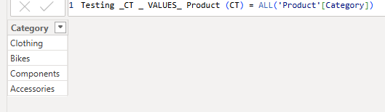
ALL() – 2 Column

Testing _CT _ VALUES_ Product -2 COL (CT) = ALL('Product'[Category], 'Product'[Subcategory])

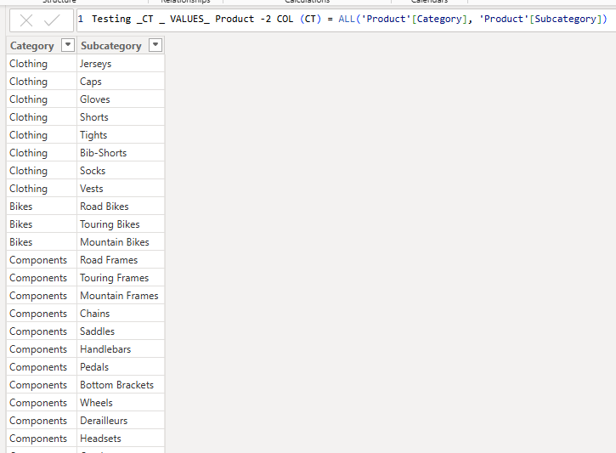
ERROR
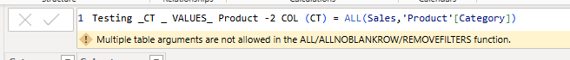
SUMMARIZE()
Testing _CT _ VALUES_ Product using Summarize(CT) = SUMMARIZE(Sales,'Product'[Category])

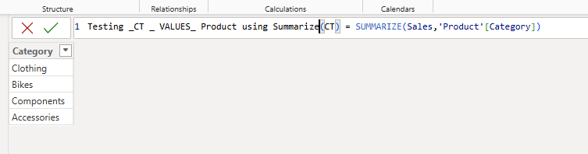
Testing _CT _ VALUES_ Product using Summarize -2 COL(CT) = SUMMARIZE(Sales,'Product'[Category],'Product'[Subcategory])

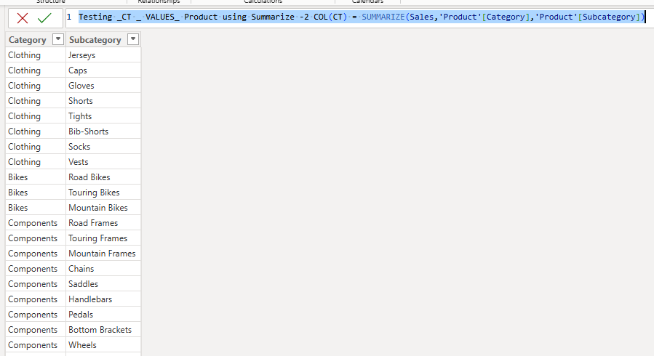
SUMMARIZE() using measure or expression for GroupBy
Testing _CT _ VALUES_ Product using Summarize -using Measures(CT) =
SUMMARIZE(
Sales,
'Product'[Category],
'Product'[Subcategory],
"Sales",SUM(Sales[Sales Amount]),
"Total Cost", SUM(Sales[Total Product Cost])
)

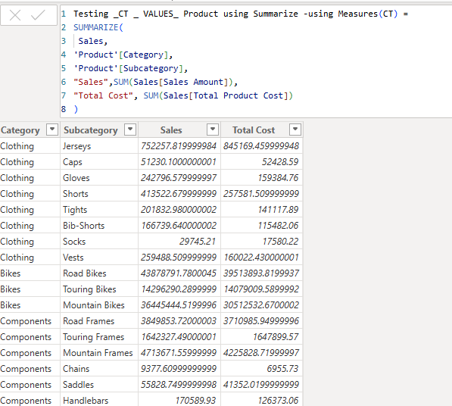
SUMMARIZE() to get data for all categories:
Testing _CT _ VALUES_ Product using Summarize -all category(CT) =
SUMMARIZE(
'Product',
'Product'[Category],
'Product'[Subcategory]
)

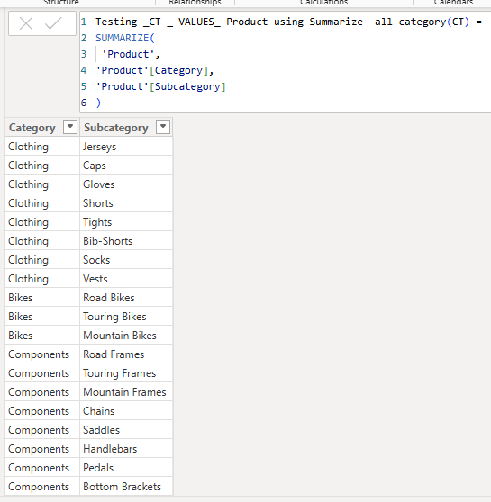
Total Sales Amount (CM) = SUM(Sales[Sales Amount])

Testing _CT _ VALUES_ Product using Summarize -all category(CT) =
SUMMARIZE(
'Product',
'Product'[Category],
'Product'[Subcategory],
"SALES", [Total Sales Amount (CM)]
)

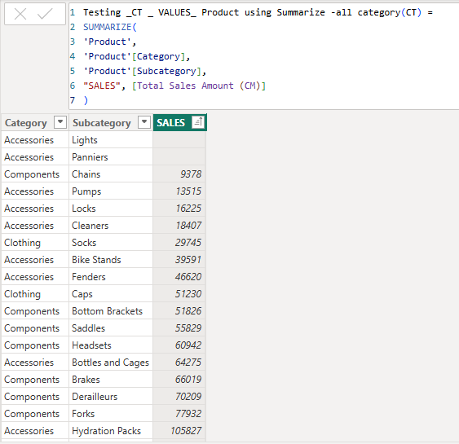
ALLEXCEPT

Testing _CT _ VALUES_ Product using ALLEXCEPT = ALLEXCEPT('Product', 'Product'[ProductKey])
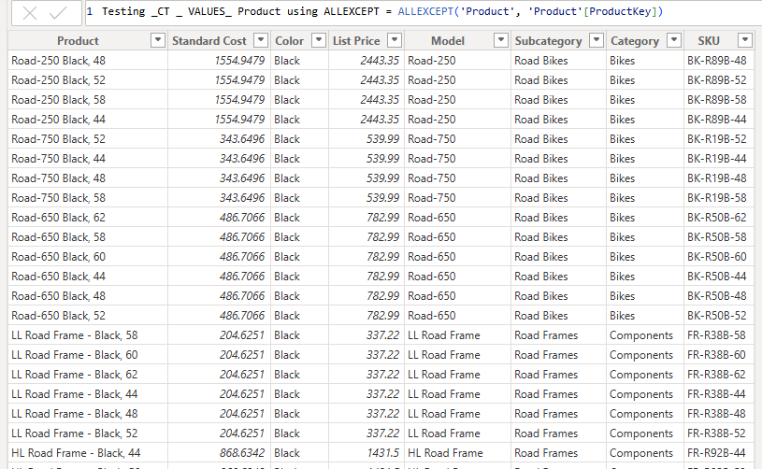
FILTER()
Testing_CT_Product using Fiter (CT) = FILTER('Product', 'Product'[Category] = "Accessories")

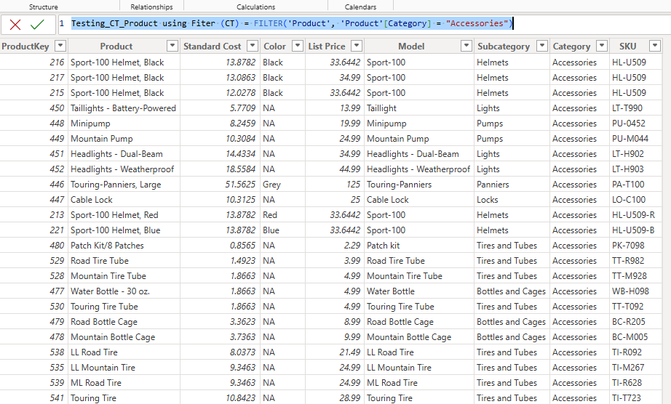
Multiple Filter:
Testing_CT_Product using Fiter (CT) =
FILTER('Product',
'Product'[Category] = "Accessories"
&& 'Product'[List Price]>30
)

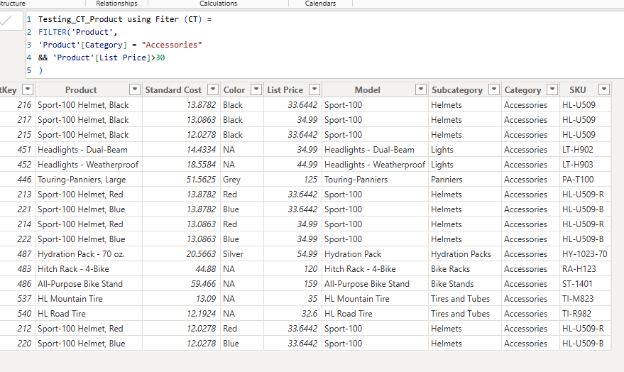
Virtual table lineage
CM
Imaginary Table of customer with sales greater than $5000 =
CALCULATE( COUNTROWS(Customer),
FILTER(Customer,[Total Sales Amount (CM)]>5000)
)

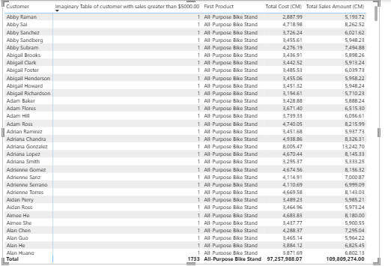
CT
Imaginary_Customer_Sales_Above5000 =
FILTER (
Customer,
[Total Sales Amount (CM)] >= 5000
)

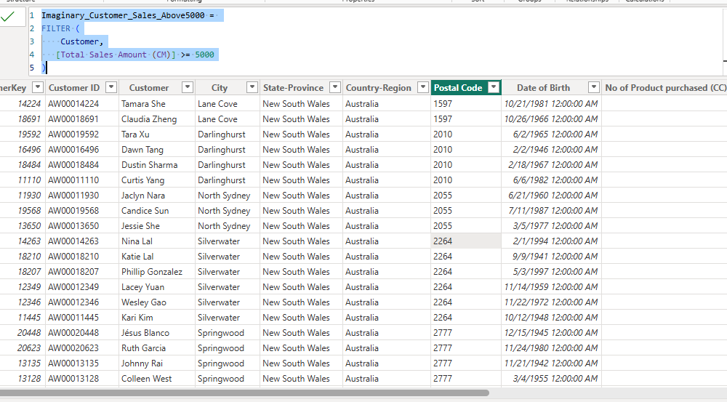
Mixing_TAB_Filter_ALL (CT)

Mixing_TAB_Filter_ALL =
FILTER (
ALL ( 'Product'[Category],'Product'[Product],'Product'[List Price]),
'Product'[Category] = "Accessories" &&
'Product'[List Price] > 30
)

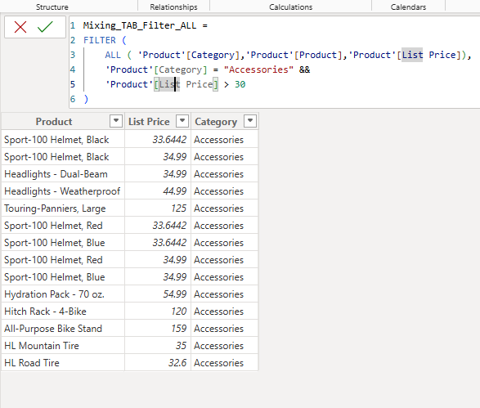
Mixing_TAB_Summarize_Filter (CT) =

Mixing_TAB_Summarize_Filter (CT) =
FILTER(
SUMMARIZE(
'Product',
'Product'[Category],
'Product'[Subcategory],
"Sales", [Total Sales Amount (CM)]
),
'Product'[Category]= "Clothing"
&& [Total Sales Amount (CM)]> 250000
)

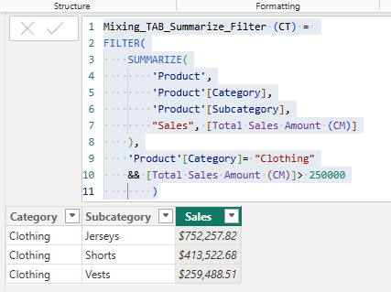
CROSS JOIN(tablee1,table2)
Testing_Cross_Join (CT) = CROSSJOIN(Customer,'Product')

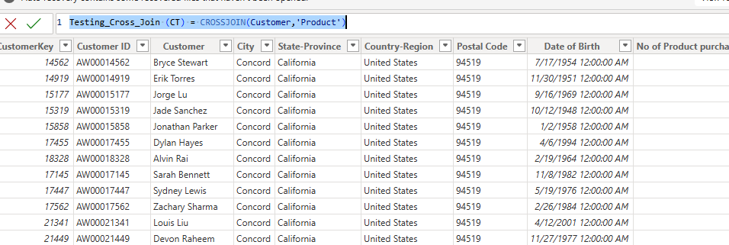
Testing_Cross_Join using Values (CT) = CROSSJOIN(VALUES(Customer[City]),VALUES('Product'[Subcategory]))
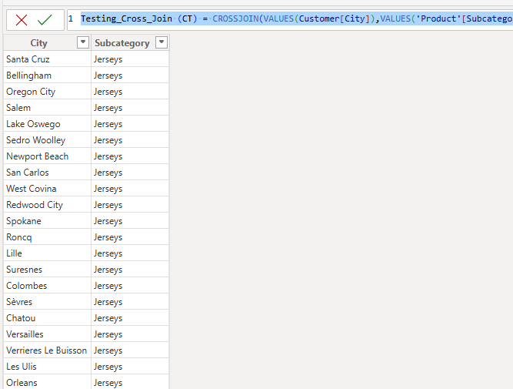
Summarize, Vaues, Cross join

Testing Cross join, Summarize,Values (CT) =
SUMMARIZE(CROSSJOIN(VALUES(Customer[City]),VALUES('Product'[Subcategory])),
Customer[City],
'Product'[Subcategory],
"Sales", [Total Sales Amount (CM)])

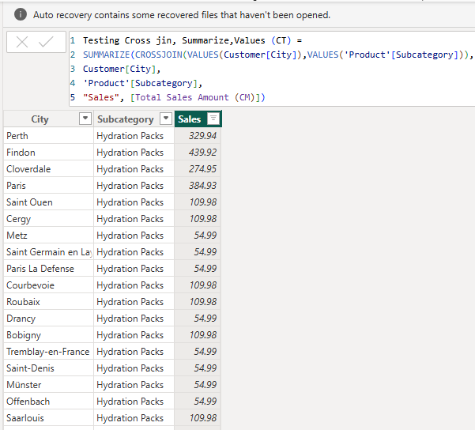
Testing Table in Measure (CM)
Testing Table using Measures = COUNTROWS(Values('Product'))
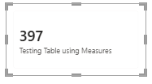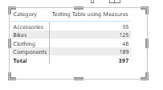
Testing Table using Measures (CM) = COUNTROWS(Values('Product'[Product]))
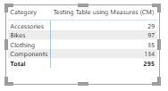
Testing Table using Measures (CM) = COUNTROWS(Values('Product'[Subcategory]))
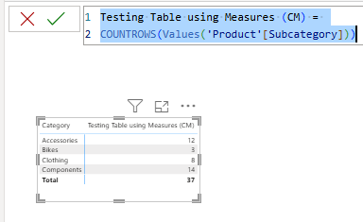
Testing Table using Measures (CM) = COUNTROWS(ALL('Product'[Subcategory]))
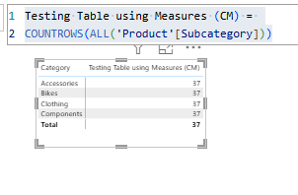
Testing Table using Measures (CM) = COUNTROWS(ALL('Product'[Category]))
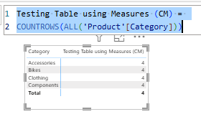
VALUES(), DISTINCT(), ALL() and ALLNOBLANKROW()
CountRows using VAlUE (CM) = COUNTROWS(VALUES('Product'))
CountRows using DISTINCT (CM) = COUNTROWS(DISTINCT('Product'))
CountRows using ALL (CM) = COUNTROWS(ALL('Product'))

CountRows using ALLNOBLANK (CM) = COUNTROWS(ALLNOBLANKROW('Product'))

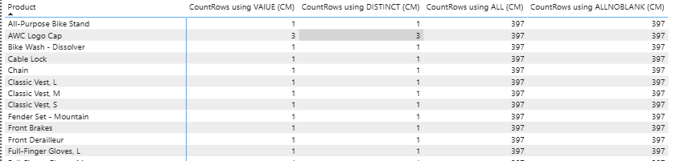
Variables and Comments in DAX
Testing Variables (CM) =
VAR TotalQuantity = SUM(Sales[Order Quantity])
RETURN
TotalQuantity

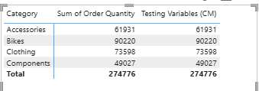
Testing Variables (CM) =
VAR TotalQuantity = SUM(Sales[Order Quantity])
RETURN
IF(TotalQuantity >1000, TotalQuantity*0.95, TotalQuantity*1.25)

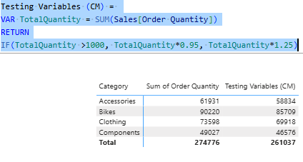
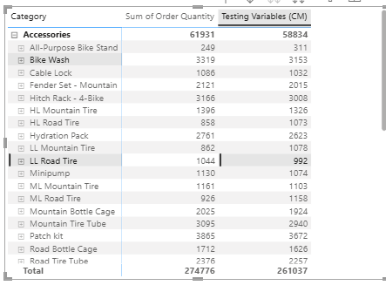
No of Premium Bikes (CM) =
VAR PremiumBikeListPrice = 3000
VAR BikeCategoryProduct =
FILTER('Product','Product'[Category]="Bikes")
VAR PremiumBikeCategoryProducts =
FILTER(BikeCategoryProduct,'Product'[List Price] > PremiumBikeListPrice)
RETURN
COUNTROWS(PremiumBikeCategoryProducts)

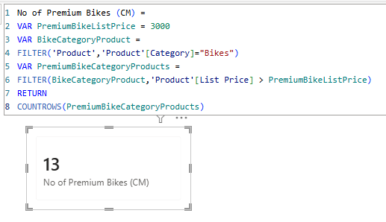
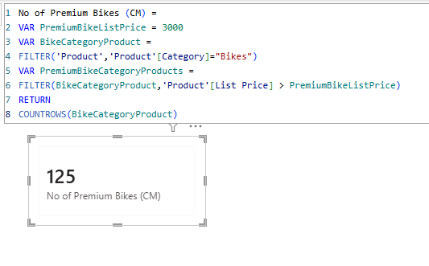
Iterators
Discount Amount (CM) =
SUMX(Sales,Sales[Unit Price Discount Pct] * Sales[Extended Amount])

Discount Amount Wrong (CM) =
SUM(Sales[Unit Price Discount Pct]) * SUM(Sales[Extended Amount])

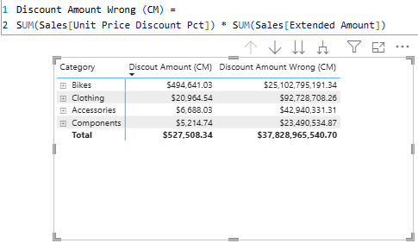
Discount Amount Large Sales (CM) =
VAR LargeSalesTable =
FILTER(Sales,Sales[Order Quantity] >10)
RETURN
SUMX( LargeSalesTable,
Sales[Unit Price Discount Pct] * Sales[Extended Amount])

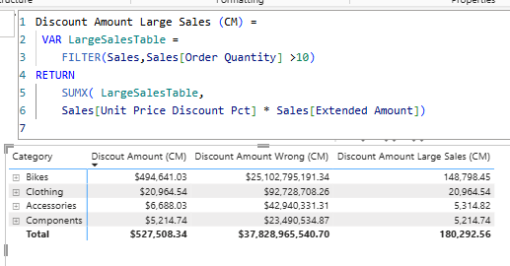
AVERAGEX() : to find the average delivery days
Average Deivery Date (CM) =
AVERAGEX(Sales, Sales[DeliveryDate]-Sales[OrderDate])

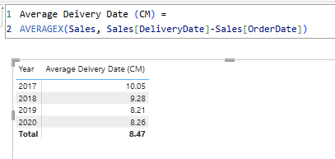
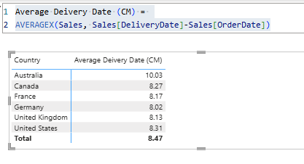
Bonus Amount (CM) =
SUMX (
Sales,
IF (
RELATED ( 'Date'[WorkingDays] ) = "WEEKDAY", //Weedend: Friday & Saturday
Sales[Sales Amount] * 0.01,
Sales[Sales Amount] * 0.02
)
)

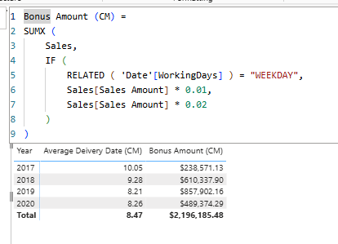
MINX(), MAXX()
Minimum Sales Per Customer (CC) = MINX(RELATEDTABLE(Sales),Sales[Sales Amount])

Maximum Sales Per Customer(CC) = MAXX(RELATEDTABLE(Sales),Sales[Sales Amount])

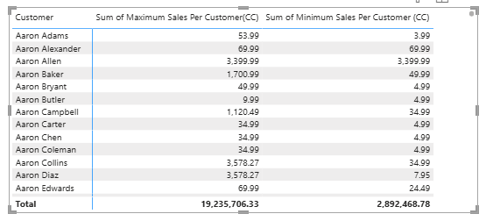
AVERAGEX()
Average SAles Per Product (CM) = AVERAGEX('Product',[Total Sales Amount (CM)])

Average Sales Per Product without context Transistion (CM) = AVERAGEX('Product',SUM(Sales[Sales Amount]))

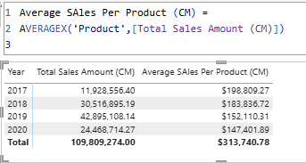
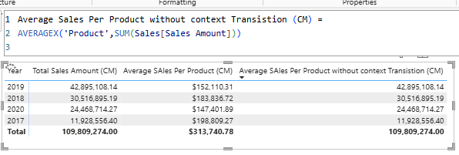
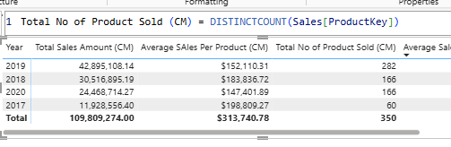
Average Sales (CM) = AVERAGE(Sales[Sales Amount])

No Of Sales (CM) = COUNTROWS(Sales)

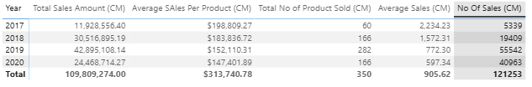
Advance Filtering in DAX
Calculate:
F_SALES In Australia (CM) = CALCULATE([Total Sales Amount (CM)],SalesTerritory[Country]="Australia")
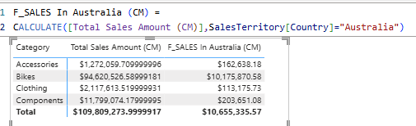
F_Australia Sales % = DIVIDE([F_SALES In Australia (CM)],[Total Sales Amount (CM)],0)

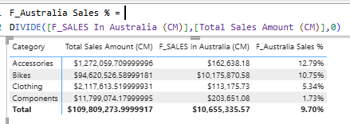
F_SALES In Australia 2 (CM) =
CALCULATE(
[Total Sales Amount (CM)],
FILTER(
ALL(SalesTerritory[Country]),
SalesTerritory[Country]= "Australia"
)
)

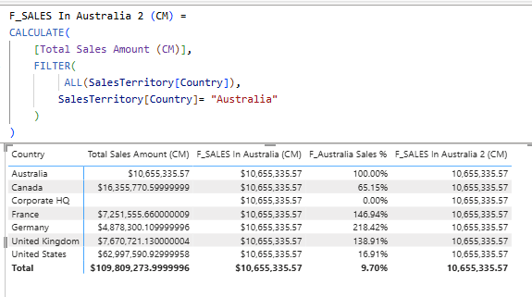
INTERSECT()
KEEPFILTER()
F_Sales in AUS KeepFilter (CM) =
CALCULATE([Total Sales Amount (CM)],
KEEPFILTERS(SalesTerritory[Country] = "Australia"))

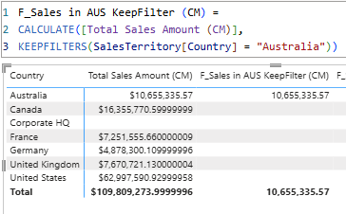
Multiple Filter
F_Sales in AUS & CAN =
CALCULATE([Total Sales Amount (CM)],
(SalesTerritory[Country] = "Australia" || SalesTerritory[Country] = "Canada"))
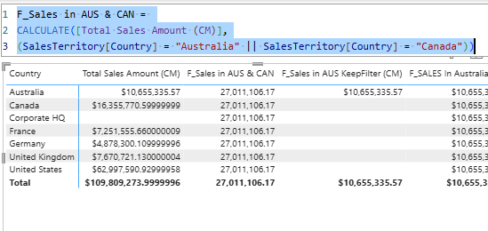
F_Sales in AUS & CAN KeepFIlter (CM) =
CALCULATE([Total Sales Amount (CM)],
KEEPFILTERS(SalesTerritory[Country] = "Australia" || SalesTerritory[Country] = "Canada"))

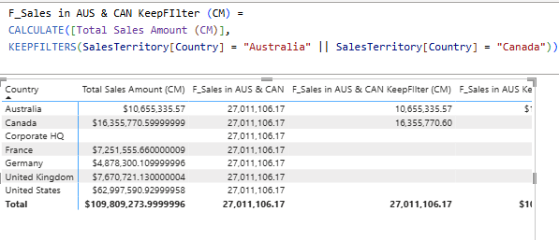
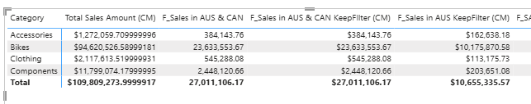
IN Keyword
F_Sales in AUS & CAN & UK(CM) =
CALCULATE([Total Sales Amount (CM)],
SalesTerritory[Country] IN { "Australia", "Canada", "United Kingdom"}
)

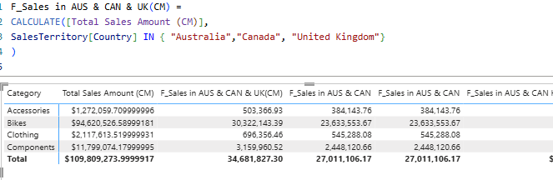
Using Filter with Cslculate
I_Sales when Discount > 500 (CM) =
CALCULATE([Total Sales Amount (CM)],
FILTER(Sales,[Discout Amount (CM)] > 500)
)

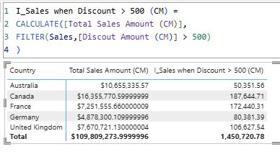
ALL Sales Amount (CM) = CALCULATE([Total Sales Amount (CM)],ALL(SalesTerritory[Country]))
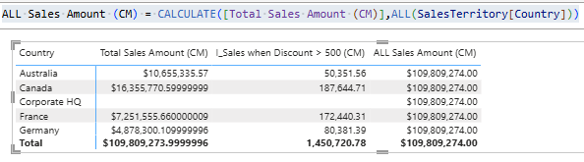
A_ RM Sales Amount (CM) = CALCULATE([Total Sales Amount (CM)],REMOVEFILTERS(SalesTerritory[Country]))

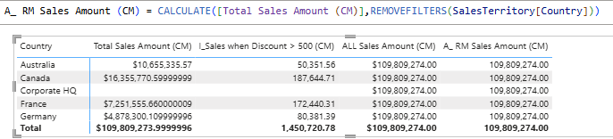
A_ % of Total Sales (CM) = DIVIDE([Total Sales Amount (CM)],[A_ ALL Sales Amount (CM)],0)

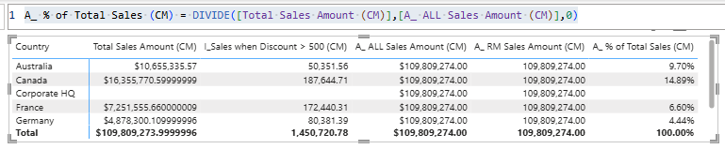
Slider to test ALLSELECTED
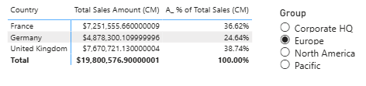
_A ALLselected Country Sales (CM)= CALCULATE([Total Sales Amount (CM)], ALLSELECTED(SalesTerritory))
_A % of Total Sales using ALLSELECTED (CM) =
DIVIDE([Total Sales Amount (CM)],[_A ALLselected Country Sales (CM)],0)

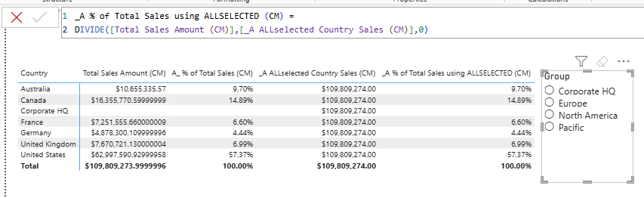
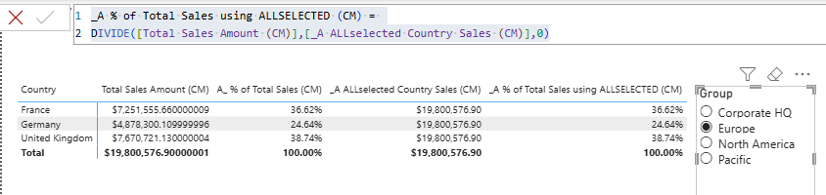
Time Intelligence
TI_Custom YTD (CM) =
CALCULATE(
SUM(Sales[Sales Amount]),
'Date'[Date] >= DATE(2018,1,1)
&& 'Date'[Date] <= DATE(2018,5,18)
)

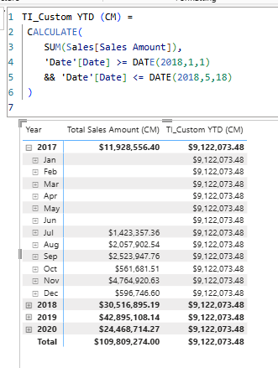
DATESBETWEEN()
TI_Custom YTD DB (CM) =
CALCULATE(
SUM(Sales[Sales Amount]),
DATESBETWEEN('Date'[Date],DATE(2018,1,1),DATE(2018,5,18)
)
)

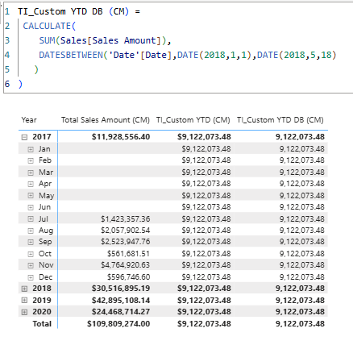
TI_ Custom YTD using Variable =
VAR LastDateOfSales = MAX('Date'[Date])
RETURN
CALCULATE(
SUM(Sales[Sales Amount]),
DATESBETWEEN('Date'[Date],DATE(YEAR(LastDateOfSales),1,1),
LastDateOfSales)
)

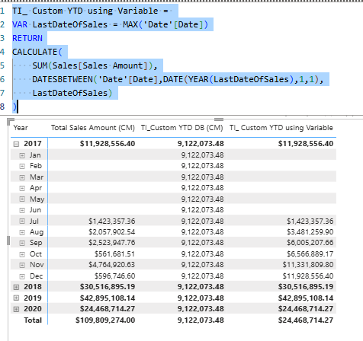
Using DATESYTD()
TI_Sales Amount YTD using DATESYD (CM) = CALCULATE([Total Sales Amount (CM)], DATESYTD('Date'[Date]))

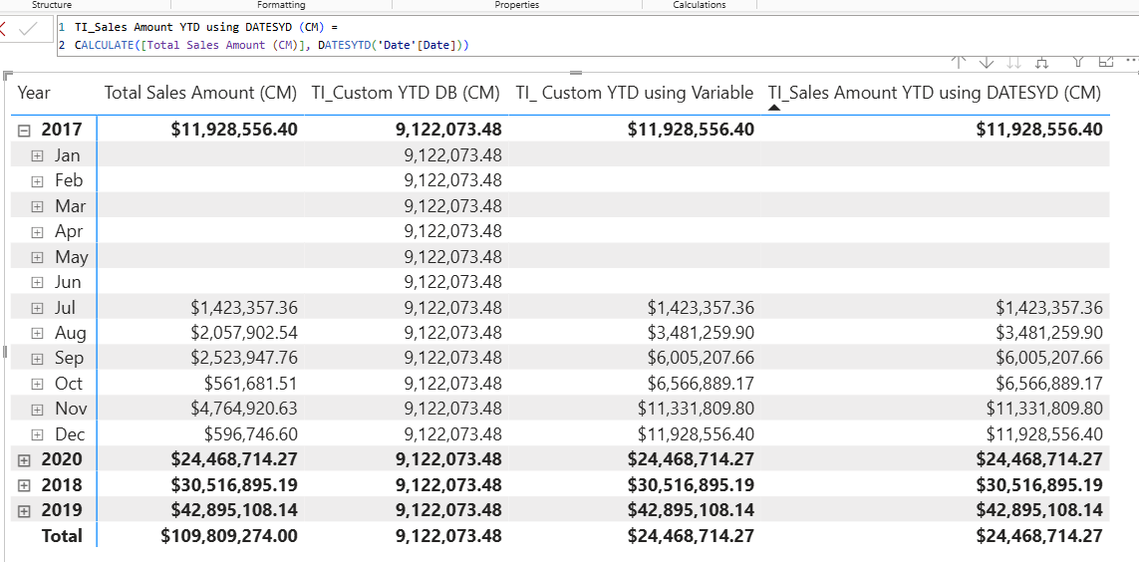
Using TOTALYTD()
TI_Sales Amount YTD using TOTALYTD (CM) =
TOTALYTD([Total Sales Amount (CM)],'Date'[Date])

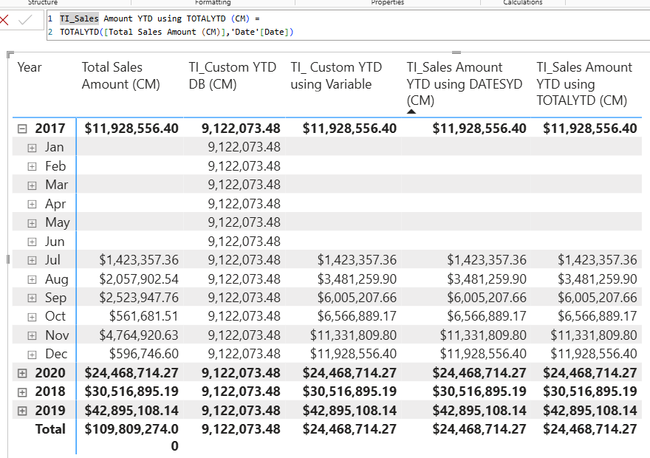
Handling Fiscal Year
TI_Sales Amount YTD for Fiscal Year (CM) = TOTALYTD([Total Sales Amount (CM)],'Date'[Date],"06-30")

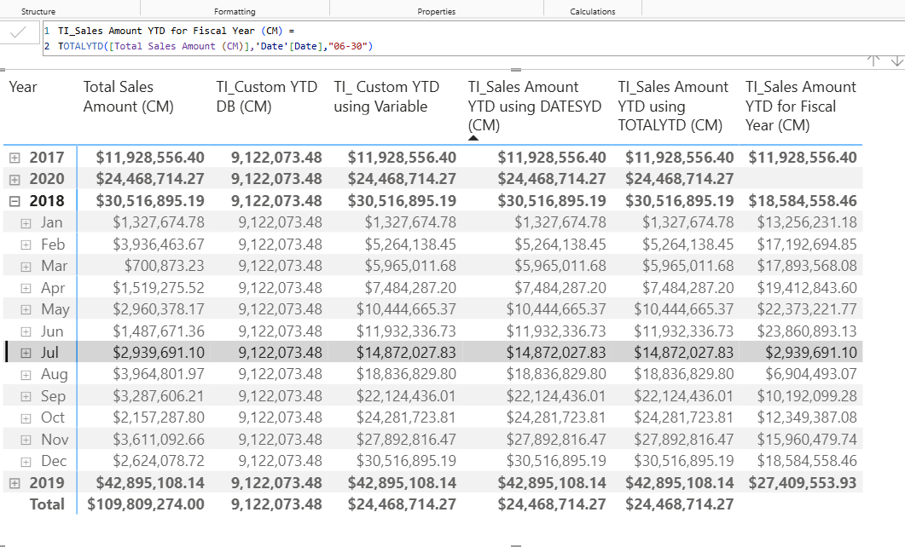
SAME PRICE LAST YEAR
DATEADD()
TI_Sale SPLY using DATEADD (CM) = CALCULATE([Total Sales Amount (CM)],DATEADD('Date'[Date],-1,YEAR)
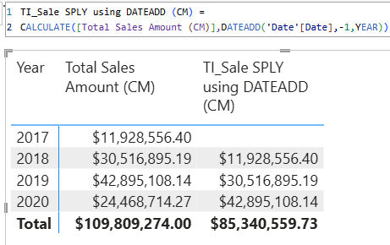
Using SAMEPERIODLASTYEAR()
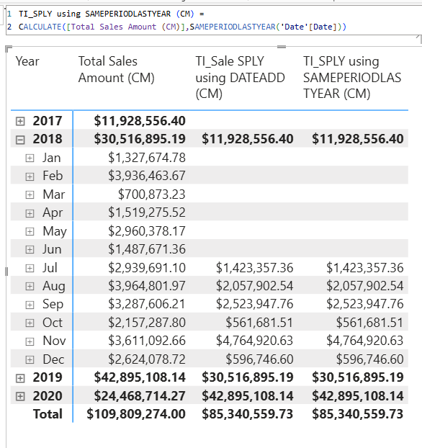
Finding YOY %
TI_ Custom YOY% (CM)=
VAR CurrentSales =[Total Sales Amount (CM)]
VAR PreviousSales = [TI_SPLY using SAMEPERIODLASTYEAR (CM)]
VAR DeltaSales = CurrentSales-PreviousSales
VAR Result =
IF(NOT ISBLANK(CurrentSales),DIVIDE(DeltaSales,PreviousSales))
RETURN
Result

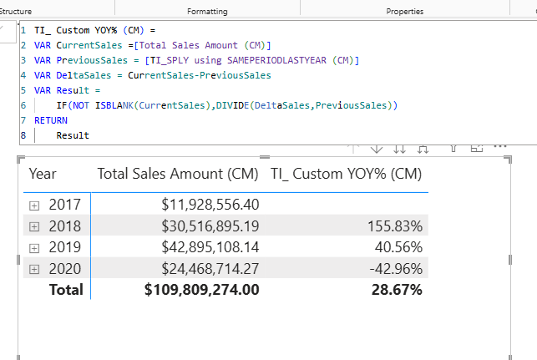
YOY% =(Current Year Value – Previous Year Value)/Previous Year value
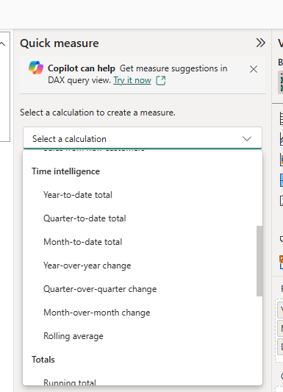 | 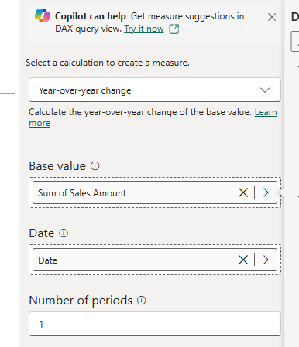
Quick Measure

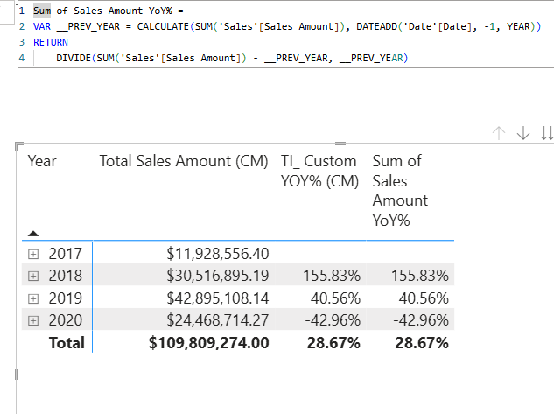
Using PARALLELPERIOD()
TI_Sales PPLY (CM)=
CALCULATE([Total Sales Amount (CM)],
PARALLELPERIOD('Date'[Date],-1,YEAR)

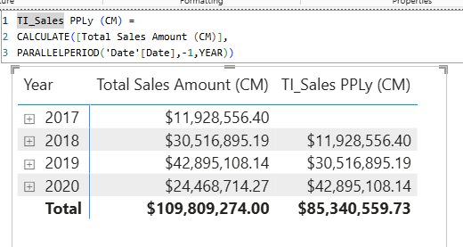
TI_ % Sales compared to last Year (CM) =
DIVIDE([TI_Sales Amount YTD using TOTALYTD (CM)],[TI_Sales PPLy (CM)])

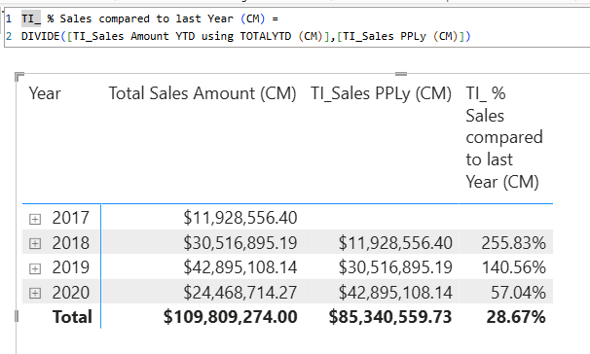
FINDING MOVING TOTAL
Using DATESINPERIOD()
Moving Total for 12 Months (CM) =
CALCULATE(
[Total Sales Amount (CM)],
DATESINPERIOD('Date'[Date],MAX('Date'[Date]),-1,YEAR)

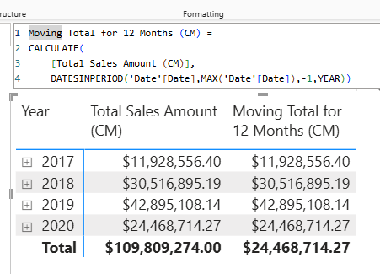
Running Total
Running Total (CM)=
VAR LastVisibleDate =
MAX('Date'[Date])
RETURN
CALCULATE(
[Total Sales Amount (CM)],
FILTER(ALL('Date'),'Date'[Date] <= LastVisibleDate)

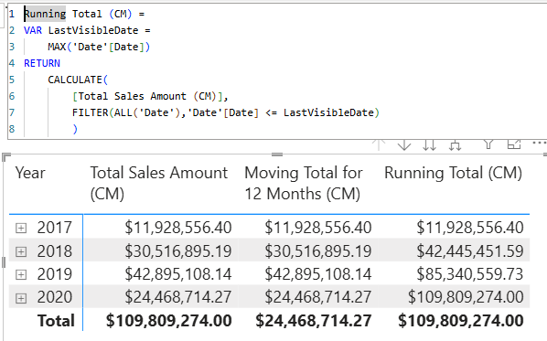
Conditionals in DAX
IF()
CC :
Product Profit (CC) = 'Product'[List Price] - 'Product'[Standard Cost]

Product Profit % (CC) = 'Product'[Product Profit (CC)]/ 'Product'[List Price]

Product Group (CC) =
IF('Product'[Product Profit % (CC)]>0.5, "HIGH",
IF('Product'[Product Profit % (CC)]>0.3,"Medium","Low")
)

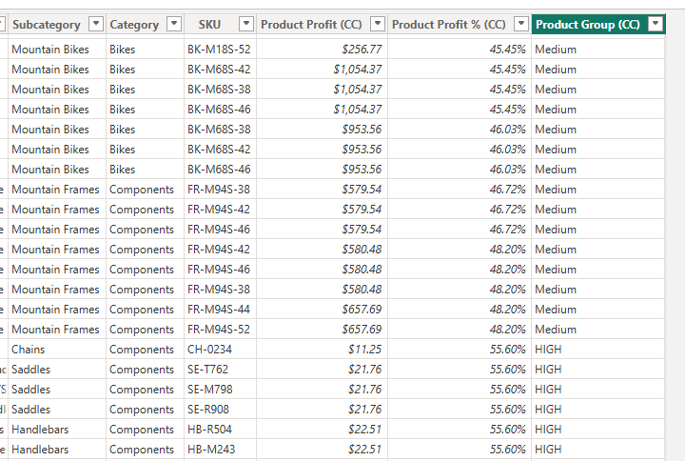
Using Switch()
Profit Group -Switch (CC) =
SWITCH(
TRUE(),
'Product'[Product Profit % (CC)] > 0.6, "V.High",
'Product'[Product Profit % (CC)] > 0.5, "High",
'Product'[Product Profit % (CC)] > 0.4, "Medium",
'Product'[Product Profit % (CC)] > 0.3, "Low",
"V.Low"
)

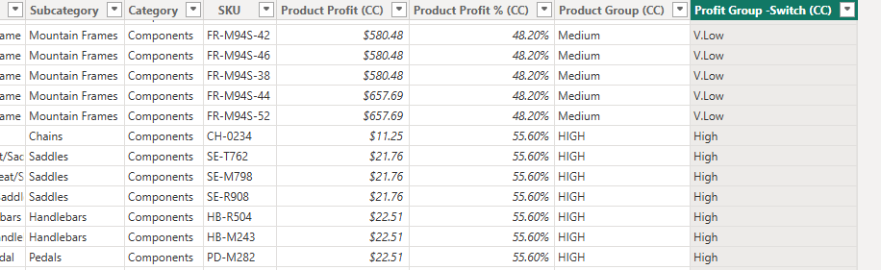
Profit Group-SORT -Switch (CC) =
SWITCH(
TRUE(),
'Product'[Product Profit % (CC)] > 0.6, 1,
'Product'[Product Profit % (CC)] > 0.5, 2,
'Product'[Product Profit % (CC)] > 0.4, 3,
'Product'[Product Profit % (CC)] > 0.3, 4,
5
)

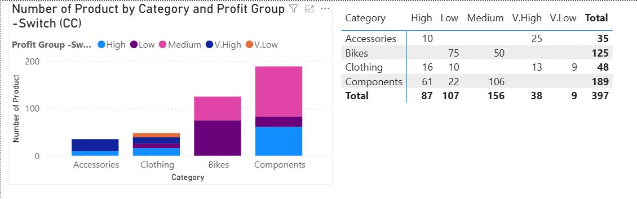
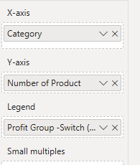
Switching Between Cases using Switch
New Discount (CC) =
SWITCH(
TRUE(),
'Product'[Color] = "Red", 0.50,
AND('Product'[Profit Group -Switch (CC)]="Low",'Product'[Color]="Yellow"),0.40, 0
)

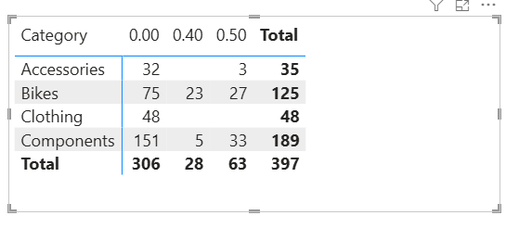
Finding Your Text
Finding Road Products (CC) = FIND("Road", 'Product'[Model],1,0)

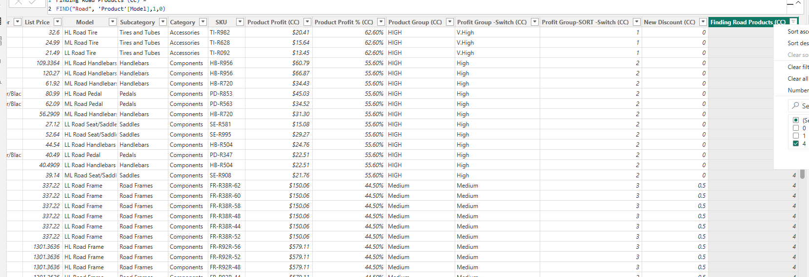
Other Function
Using CONCATENATEX()
X MAX Daily Sales =
MAXX('Date' ,[Total Sales Amount (CM)])

X Date of MAX Sales (CM =
VAR MaxDailySales = [X MAX Daily Sales]
VAR DateWithMaxSales =
FILTER('Date',[Total Sales Amount (CM)]= MaxDailySales)
VAR Result =
CONCATENATEX( DateWithMaxSales, FORMAT('Date'[Date], "mm/dd/yy"),", " )
RETURN
IF(NOT ISBLANK(MaxDailySales), Result, BLANK())

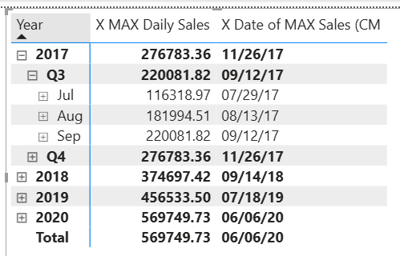
HASONEVALUE() & CONCATENATEX()
HX Product Keys of Duplicate Products (CM) =
IF (
HASONEVALUE('Product'[Product]),
CONCATENATEX('Product','Product'[ProductKey],",")))

HX Product List Price of Duplicate Products (CM) =
IF(
HASONEVALUE('Product'[Product]),
CONCATENATEX('Product',ROUND('Product'[List Price],1),", "))

